TOUR MATE CAB SERVICE SYSTEM ….

MAY 23, 2020

SAVINDU PASINTHA LAKAMAL MUNASINGHE

NG/HNDCSE/24/11

11HIGHER NATIONAL DIPLOMA IN COMPUTING & SOFTWARE ENGINEERING

**Assignment Cover Sheet**

|  |  |  |  |
| --- | --- | --- | --- |
| **Qualification** | | **Module Number and Title** | |
| Higher National Diploma in Computing & software Engineering | | SEC4204 - Fundamentals in Computer programming | |
| **Student Name & No.** | | **Assessor** | |
| T.M.Savindu Pasingtha NG/HNDCSE/24/11 | | Mr. Dhanusha Somawardhana | |
| **Hand out date** | | | **Submission Date** |
| **05/ 02 /2020** | | | **29/03/2020** |
| **Assessment type**  Coursework 1 (design Document)    Coursework 2 (Software project with test document) | **Duration/Length of**  **Assessment Type**  1,000 words equivalent      2,000 words equivalent | | **Weighting of Assessment**  40%      60% |

|  |
| --- |
| **Learner declaration** |
| I, T.M.Savindu Pasingtha NG/HNDCSE/24/11, certify that the work submitted for this assignment is my own and research sources are fully acknowledged. |
| |  |  |  |  | | --- | --- | --- | --- | | **Marks Awarded** | | | | | First assessor | |  | | | IV marks | |  | | | Agreed grade | |  | | | Signature of the assessor |  | Date |  | | |

**Feedback Form**

**International College of Business & Technology**

**Module :** 4204-Fundamentals in Computer programming

**Student :** T.M.Savindu Pasingtha

**Assessor :** Mr. Danusha Somawardhana

**Assignment:**

**Strong features of your work:**

**Areas for improvement:**

**Marks Awarded:**

# ACKNOWLEDGEMENT

In preparation of my assignment, I had to take the help and guidance of some respected persons, who deserve my deepest gratitude. As the completion of this assignment gave me much pleasure, I would like to show my gratitude Mr. Dhanusha Somawardhana, our lecturer, on ICBT Campus for giving me good guidelines for assignment throughout numerous consultations. I would also like to expand my gratitude to all those who have directly and indirectly guided me in making this assignment.

# ABSTRACT

This assignment discussed about “Tour mate cab Service Company” to make a new software system for manage their main processes. Firstly, I discussed about what is the computer-programing topic. After I design what system, I create to the use company. Not only that I give for you this application to system requirement specification (SRS). Therefore, I draw flow charts and write pseudo code for my system. Then I generate my software application to c++ real program. After I tested my software application. Bellow the assignment; I have been given my test document with all the test cases.

Table of Contents

ACKNOWLEDGEMENT 3

ABSTRACT 4

Task 1 8

Computer program 8

Programming language 8

C (1972) 10

Python (1991) 10

Java (1995) 10

Php (1995) 10

C # (2002) 10

Go or go-Lang (2009) 11

C ++ 11

Variable 11

Data types 11

Operators 11

Arithmetic 11

Logical 12

Relational comparison 12

Assignment 12

Sequence 13

Selection 13

Conditional statement 13

1. If statement 13

2. If-else statement 14

3. Else if statement 15

4. Swich case statement 17

Iteration 18

Looping statement 18

While statement 18

While do statement 19

For statement 19

Modularization 20

Task 02 21

SOFTWARE REQIREMENT SPECIFICATION (SRS) 21

Introduction 21

Purpose 21

Scope 21

Budget 21

Requirement gathering methods 21

System features and requirement 21

Functional requirement 21

External requirement 22

Nonfunctional requirement 22

Flow charts 23

MAIN MENU 23

Log in 24

REGISTRATION 25

PAYMENT BILLING 26

EXIT 28

EDIT MENU 29

UPDATE MAIN MENU 30

VIEW DETAILS MAIN MENU 31

CLEAR DETAILS MAIN MENU 32

ADD COMPANY DETAILS 33

HOW TO USE THIS SOFTWARE 34

VIEW VEHICLE DETAILS 35

VIEW BOOKING DETAILS 36

VIEW DRIVER DETAILS 38

ADD VEHICLE DETAILS 39

ADD DRIVER DETAILS 40

ADD BOOKING 41

VIHICLE DETAILS DELETE 42

DRIVER DETAILS DELETE 42

BOOKINHG DETAILS DELETE 43

ABOUT COMPANY DETAILS DELETE 44

Pseudo codes 45

TASK 03 51

Program code 51

TASK 04 71

TEST CASE 71

Valid details with login 71

Invalided details with login 72

MAIN Menu 73

Payment 76

System registration 79

Add booking 80

Add drive details 82

Add company details 86

View menu 87

Edit menu 90

Clear menu 93

What is testing? 94

Functional testing 94

1. 1Unit testing- 94

2. System testing- 94

3. Integration testing- 94

4. Acceptance testing- 94

Nonfunctional testing 95

1. Performances testing- 95

2. Security testing- 95

3. Usability testing- 95

4. Compatibility testing- 95

CONCLUTION 96

GANTT CHART 97

REFERENCE 99

# Task 1

## Computer program

A program is a set of instruction written in language understandable by computer to perform particular function on computer. Well-written programs can be parceled well to from an application package customized for solving specific type of problems on the computer system. (Anon., 2017)

## Programming language

Programming language are artificial notational created or developed to be used in preparing coded instruction on the computer .they are usually composed of serious usage rules that determine the meaning of expressions written in the language. Each programming language comes handy with its own translate. (Anon., 2013)

|  |  |
| --- | --- |
| HIGH LEVEL LANGUAGE | LOW LEVEL LANGUAGE |
| High-level languages close to the human language.  Deep knowledge of hardware not required to write program.  High-level language do not provide many facilities at hardware level.  These languages are normally used to write application programs.  Ex--:  Objective C, c #, c++, java, java script, python, Cobol, Pascal, Perl, php, swift languages. | Low-level languages not close to human language.it is difficult to understand for us.  Deep knowledge of hardware is required to write programs.  Low-level languages provide facilities to write programs at hardware level.  These languages normally used to write hardware programs.  Ex--:  Assembly, machine languages. |

### C (1972)

Denial Ritchie create this as a world first high-level language. This language is very close to the human language. Come after the c language remove the machine codes. This language is very useful to develop ruby, c#, c++, go (golang), java, java script, and Perl, php and python languages. (Colleges, 2018)

### Python (1991)

Python programming language is created by Ms. Guido van Rossum .python is open source language. Python language have simple rules and simple syntax. There for it similar to the English language. Not only that some time programmers ca use another programming language with write in the python syntax. It is the very comfortable for programmers to write program. Today python program run interpreter system .Because we can executed as soon as python code write.so very quick prototyping .not only that functional way, object oriented way or procedural ways can used to tread in python.

Python language use in to,

Server to create web applications.

Database system connect and modifying.

Rapid prototyping or for production ready software development.

Create workflows for alongside software.

Handle to the big data.

Perform the complex mathematics.

Create artificial intelligence.

### Java (1995)

Java is a most popular programing language .today 3-4 billions devices run using with java .java have big demand in the world.java is an object oriented language.

We can use java for the development to the games, database connections, web server applications, desktop applications, special mobile android apps and much more.

Java is open source and free language.so it has a big community in the world.java is very easy to understand and easy to use programmers.

### Php (1995)

Php is an open source language .there for it can use easily in the windows, Linux, and other all platforms. Php can change any details in the database .not only that it can encrypted the data generate dynamic page content. Php files can contain the css and php, java script, and html codes. Not only that, php can using modify the server any things.

### C # (2002)

C # is created by microft.it is an object oriented programing language. We can run c # programs in the dot net framework (.net). Firstly c # born in a c language family. This language is very popular in world between the programmers. Because it is very easy to understand and use ++, java and c languages are close to this language.

### Go or go-Lang (2009)

Go language is open source language. Rob pike, Robert griesemer and ken thomp ware create this language. They work on the google company .programmers use to golang for create new project. Go Lang give us to our project to big security and we can do speedily its. Not only that, go Lang had python wsgi, bundler, radius and other technologies. Because we cannot use to python another language for our projects.

### C ++

C++ developed by B. jorne stroustrup using the c language .this language is a cross platform and object oriented language .because this using create high performance applications. Today we can found c ++ language in the operating systems, graphical user interfaces and embedded systems. (Anon., 2014)

## Variable

Variable used to store data and after we can obtain it content use for our task to in programming .data store in random access memory in the computer. We can create any name using variables in the programing. (Anon., n.d.)

## Data types

Data type used to recognize to what is variable content type and it using reserve the space size in the memory to store the data. (Anon., 2014)

|  |  |  |
| --- | --- | --- |
| DATA TYPE | WHAT USED STORE | RAM SPACE SIZE(bite |
| Int  Float  Double  Char  varchar  string | Whole numbers  Number with one decimal place  Number with two decimal place  Single characters in letters and number  Single letters  Words or sentences | 4  4  8 |

## Operators

### Arithmetic

Use for due to basic mathematical operations.

|  |  |
| --- | --- |
| +  -  /  *  %  --  ++ | Addition  Subtraction  division  multiplication  get remain of the division  increase the value by one  decrease the value by one |

### Logical

Use for evaluating a combine of conditions or constraints to get a resultant value.

|  |  |
| --- | --- |
| && logical not  || logical or  ! logical not | Returns true if all conditions are true, otherwise returns false.  Chose to one conditions true between other conditions.  Negates the conditions. |

### Relational comparison

Use to compare operands.

|  |  |
| --- | --- |
| = equal  != not equal to  < less than to  <= less than equal to  > greater than  >= greater than equal to | Evaluate whether two operand are equal. Returns true if equal else returns false.  Complements ‘equal to’ operator.Retuns true if operands are not equal .false otherwise.  Returns true if the first operands is less than second. False otherwise.  Returns true if the first operands is less than or equal to the second. False otherwise.  Returns true if the first operands is greater second. False otherwise.  Returns true if the first operands is greater than second. False otherwise. |

### Assignment

Assignment operator “=” is used to assigning a value to a variable. The LHS of the assignment operator is a variable and RHS is the value that is to be assigned to the variable. The value on the right side must be of the same type as that of the variable on the left-hand side. (Anon., 2014)

|  |  |  |  |  |  |  |  |  |  |  |  |
| --- | --- | --- | --- | --- | --- | --- | --- | --- | --- | --- | --- |
| =  +=  -=  *=  /= | |  |  | | --- | --- | |  | Assigns the value of RHS operand to LHS operand | |  | Adds RHS operand to LHS operand and assigns the result in LHS operand. | |  | Subtracts RHS operand to LHS operand and assigns the result to LHS operand | |  | multiplies RHS operand to LHS operand and assigns the result to LHS operand | |  | divides RHS operand to LHS operand and assigns the result to LHS operand | |

## Sequence

This mean that the computer will run your code in order ,one line at a time from the top to the bottom of your program .it will start at line one, then execute line two and line three and so on till it reaches the last line of your computer program. (Anon., 2019)

## Selection

This mean is we can select some conditions using the if statement and switch statement. (Anon., 2019)

### Conditional statement

#### If statement

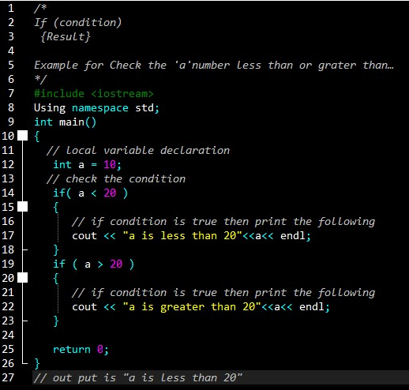

#### If-else statement

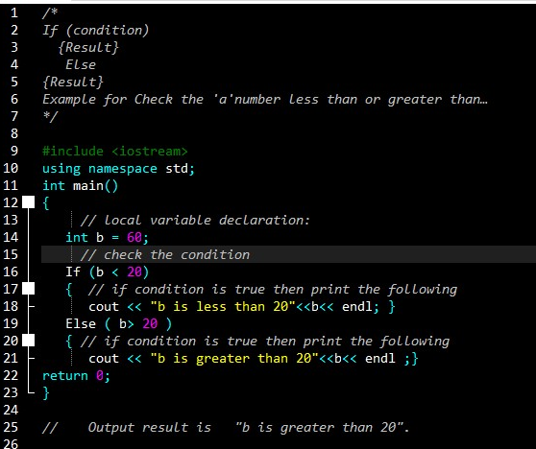

#### Else if statement

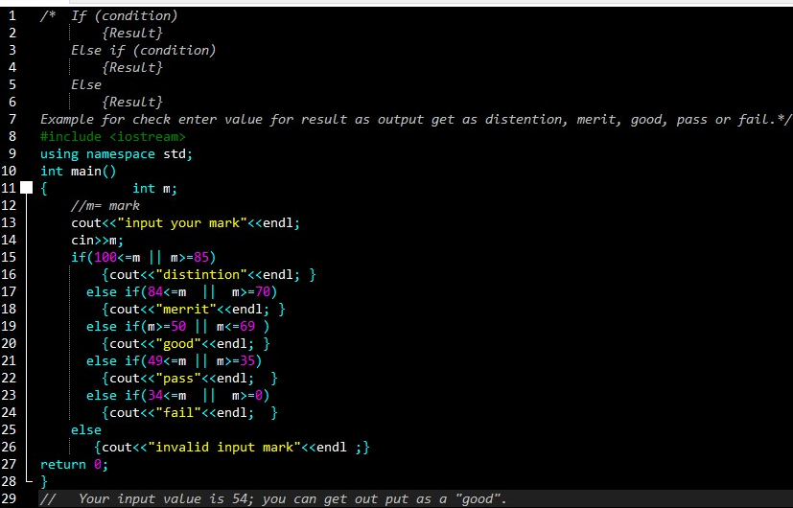

#### Swich case statement

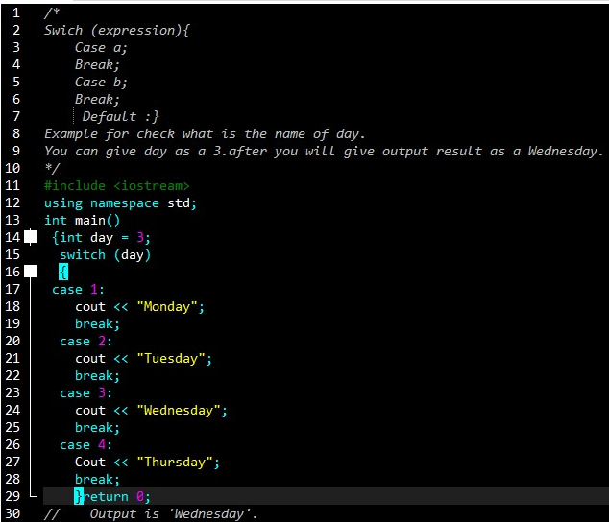

## Iteration

Iteration is a process where a set of instructions or structures are repeated in a sequence a specified number of times or until a condition is met.in programming this is commonly represented as a loop. (Anon., 2015)

## Looping statement

### While statement

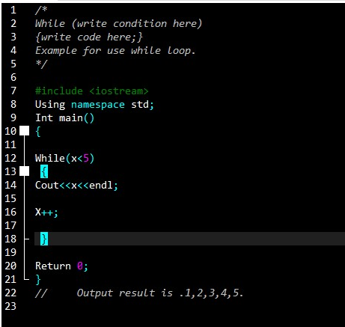

### While do statement

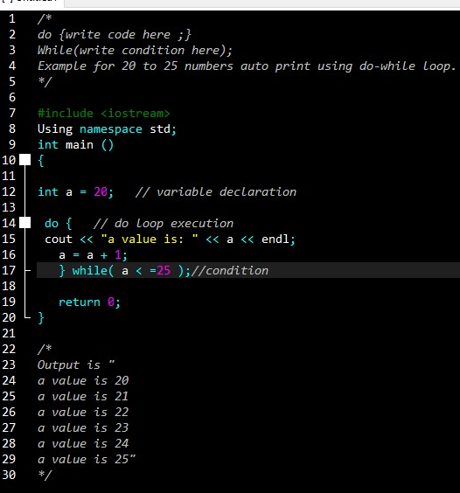

### For statement

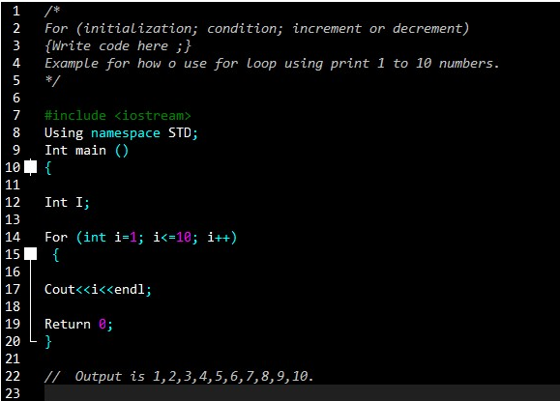

## Modularization

Modularization is a technique to divide a software system into multiple discrete and independent modules, which are expected to be capable of carrying out tasks independently. These modules may work, as basic constructs for the entire software. Designers tend to design modules such that they can be executed and or compiled separately and independently.

Modular design unintentionally follows the rule of divide and conquer problem-solving strategy. This is because there are many other benefits attached with the modular design of a software.

Advantages

* Program can be divided based on functional aspects.
* Smaller components are easier to maintain.
* Components with high cohesion can be re-used again.
* Desire level of abstraction can be brought in the program.
* Desired from security aspect.
* Concurrent execution can be made possible. (Anon., 2018)

# Task 02

## SOFTWARE REQIREMENT SPECIFICATION (SRS)

Software requirement specification is a document that describes what the software we will do is and how to it will be expected to perform. (Anon., 2018)

### Introduction

This SRS document about a TOUR MATE taxi booking and maintaining c++ software system program.

### Purpose

Tour Mate Company to want develop automation booking system program to improve their business of cab service. Therefore, this system have many feature to maintain this company main process. Such as, view-add-delete-update booking, vehicle, driver details, payment.

### Scope

Tour mate cab service system is very use full system to cab booking. I develop this system using c ++ language. This system is a very easy to use any one. This system can run the all the operating system console, such as windows, mac, Linux etc. Someone want to easy to vehicle book and company can easy to maintain this system.

### Budget

One thousand five hundred (1500) rupees spent for the data package for find details using internet.

### Requirement gathering methods

I get more details in the internet and my lecture sir helped to me any time develop this system.

### System features and requirement

#### Functional requirement

Functional requirements are part discus the functionalities requirement from the system.

1. User login
2. Registration to system
3. Booking
4. Payment
5. View vehicle, company, driver, and booking details.
6. Add vehicle, company, driver, booking details, company, details.
7. Update vehicle, company, driver, booking details, company, details.
8. Delete vehicle, company, driver, booking details, company, details.

#### External requirement

1. System date and time show any time.
2. Font size change
3. Attractive system background user interface.

#### Nonfunctional requirement

1. Safety
   1. We can safety, use software this application any time.
2. Security
   1. Vehicle and other all booking details and system document have a temporary records.
3. Portability
4. Availability
5. Reliability

## Flow charts

### MAIN MENU



### Log in



### REGISTRATION



### PAYMENT BILLING





### EXIT



### EDIT MENU



### UPDATE MAIN MENU



### VIEW DETAILS MAIN MENU



### CLEAR DETAILS MAIN MENU



### ADD COMPANY DETAILS



### HOW TO USE THIS SOFTWARE



### VIEW VEHICLE DETAILS



### VIEW BOOKING DETAILS

VIEW ABOUT COMPANY DETAILS



### VIEW DRIVER DETAILS



### ADD VEHICLE DETAILS



### ADD DRIVER DETAILS



### ADD BOOKING



### VIHICLE DETAILS DELETE



### DRIVER DETAILS DELETE



### BOOKINHG DETAILS DELETE



### ABOUT COMPANY DETAILS DELETE



## Pseudo codes

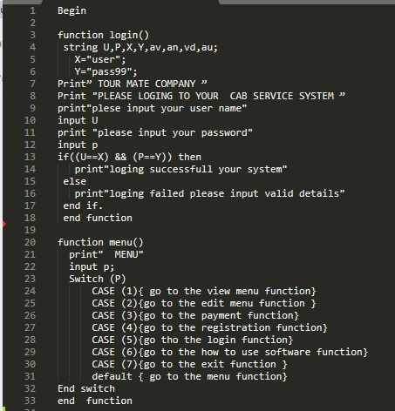

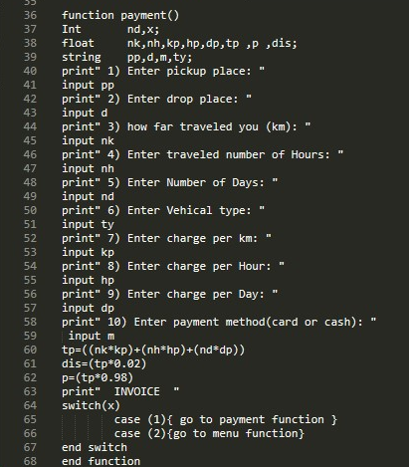

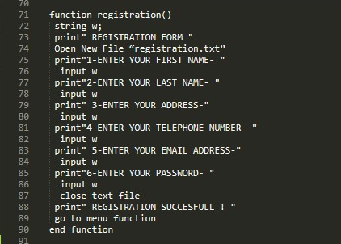

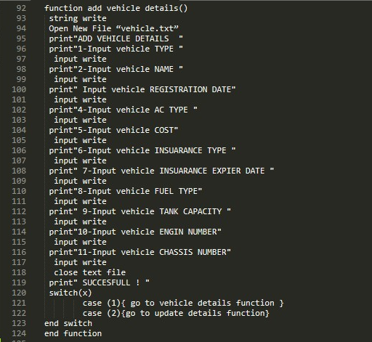

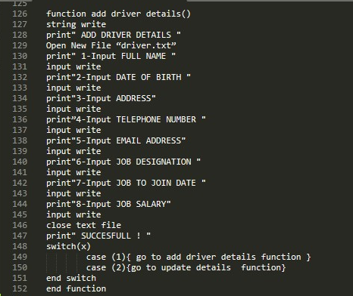

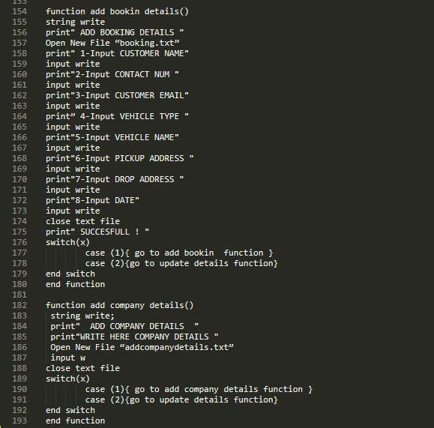

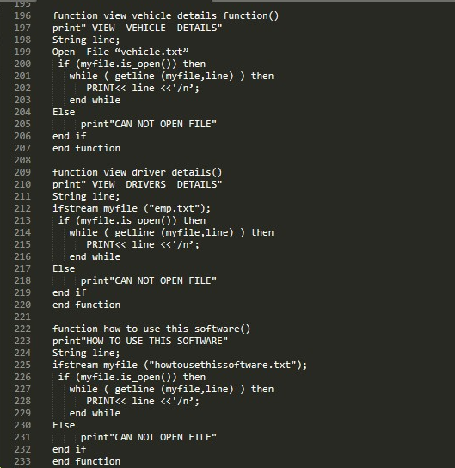

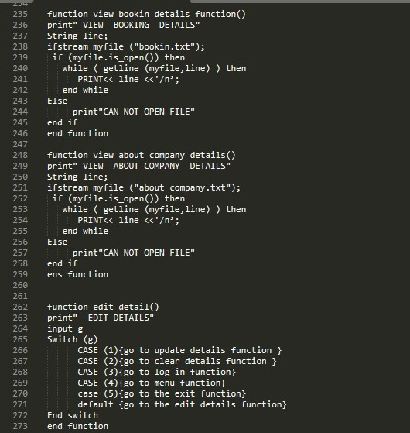

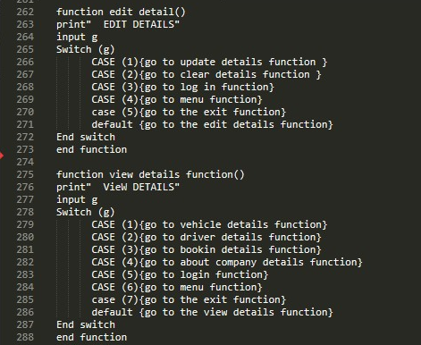

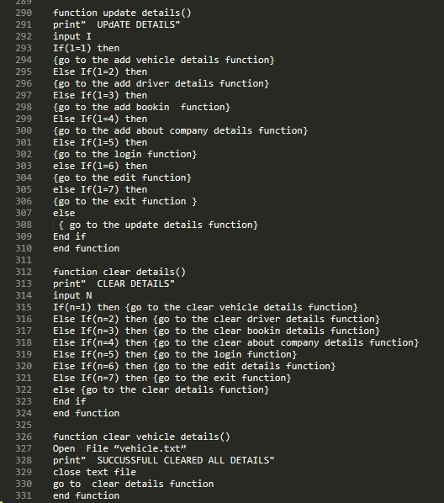

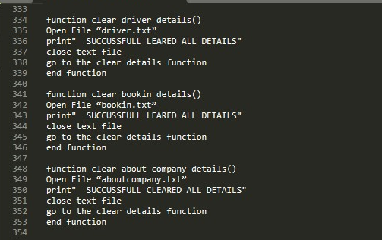

# TASK 03

## Program code

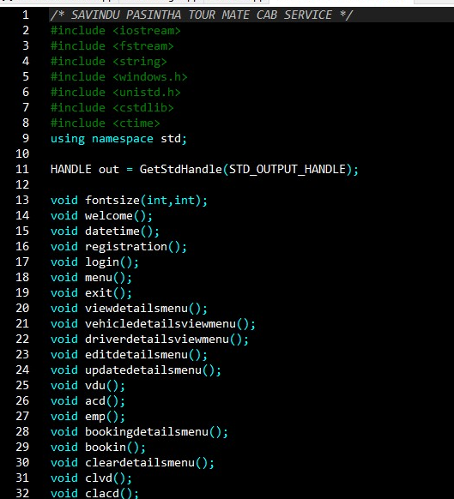

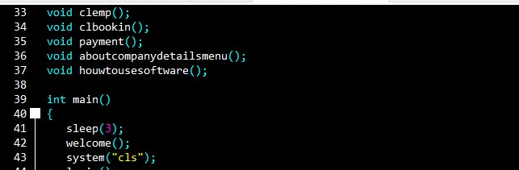

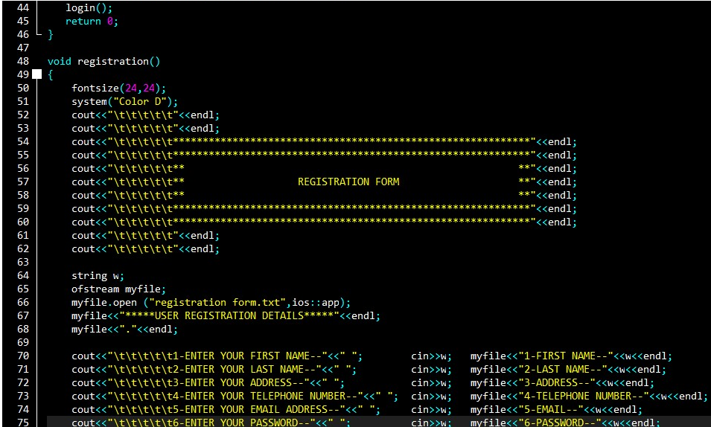

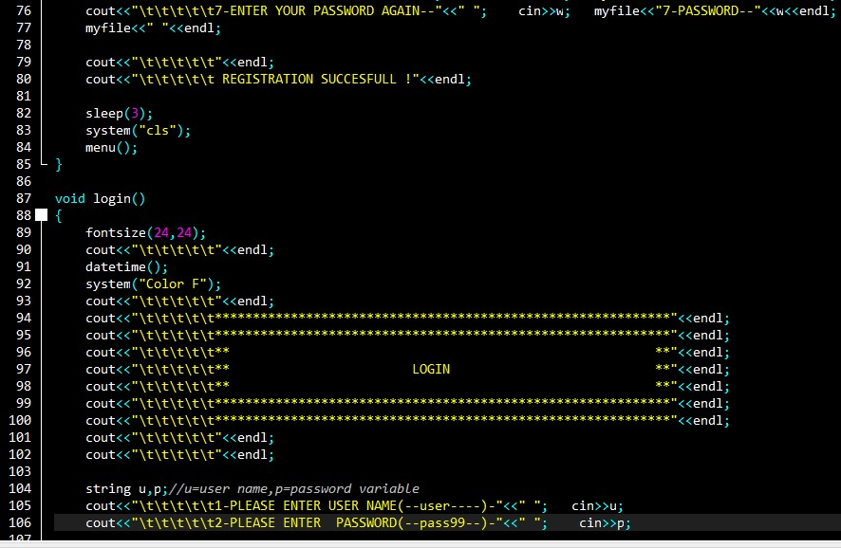

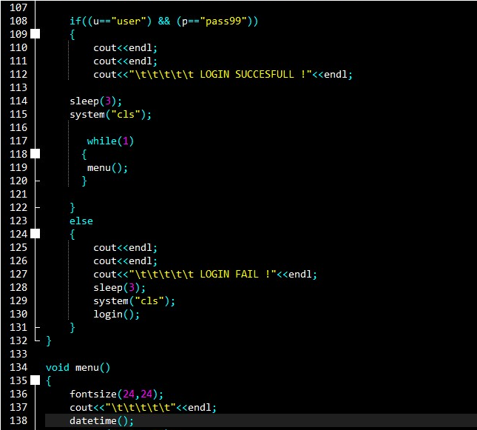

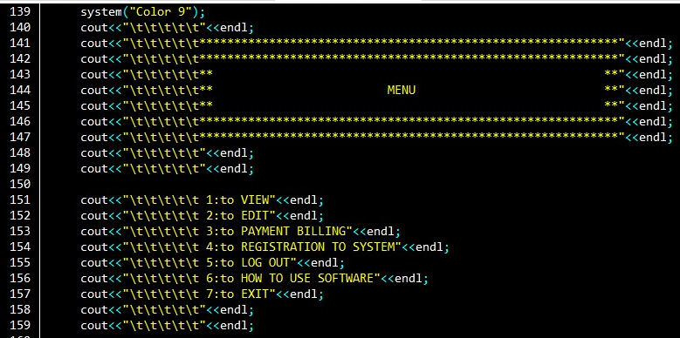

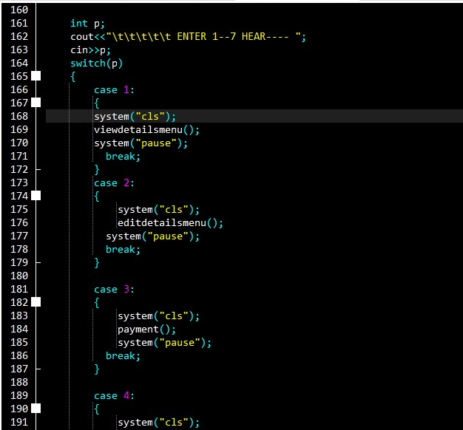

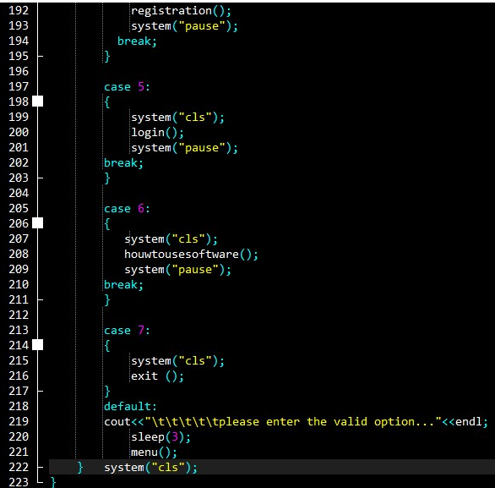

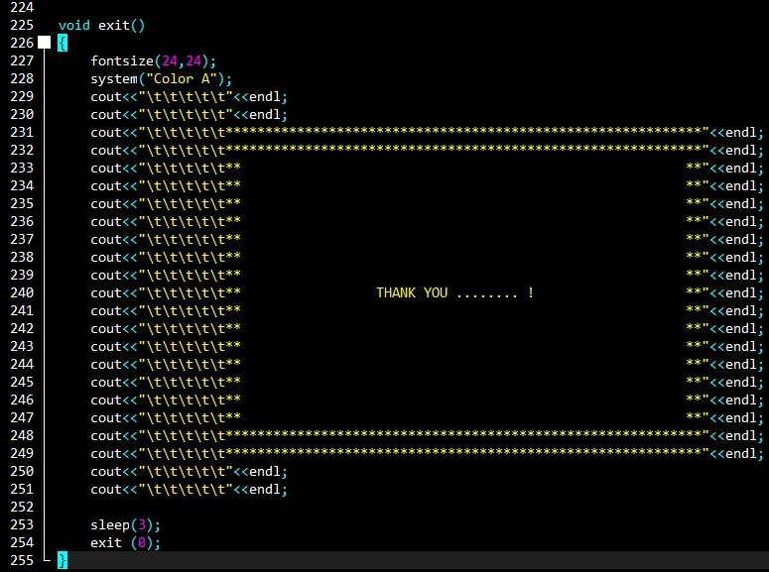

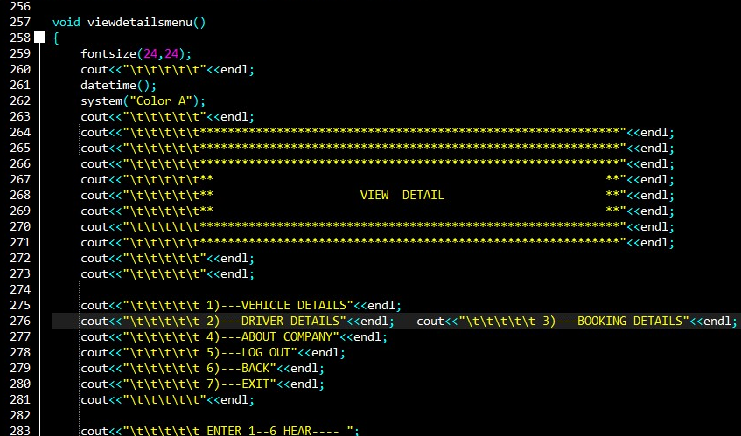

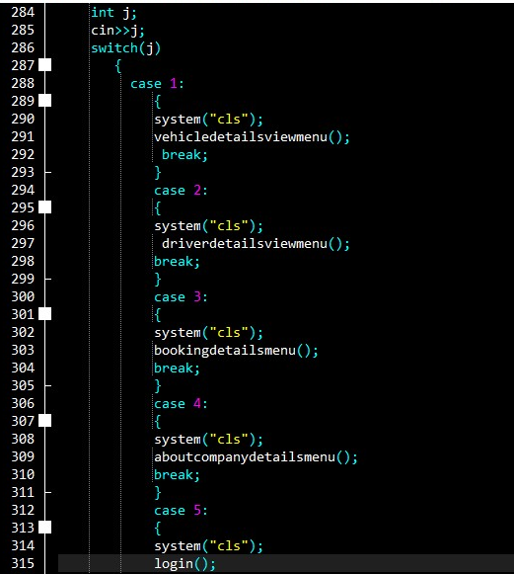

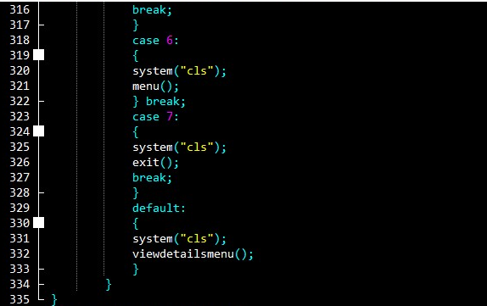

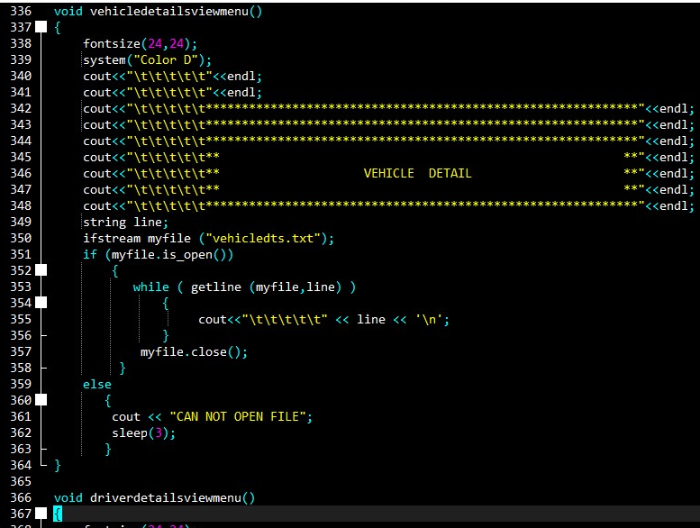

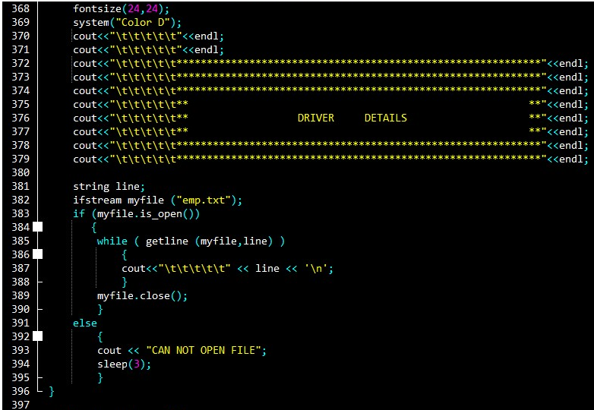

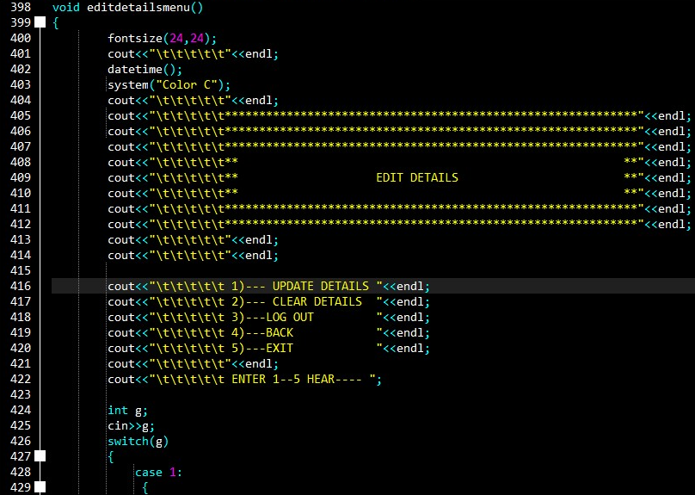

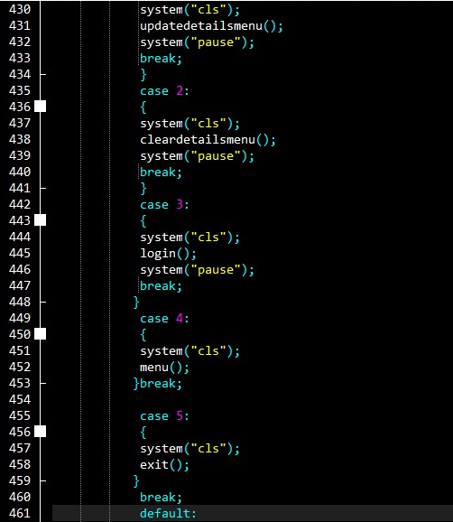

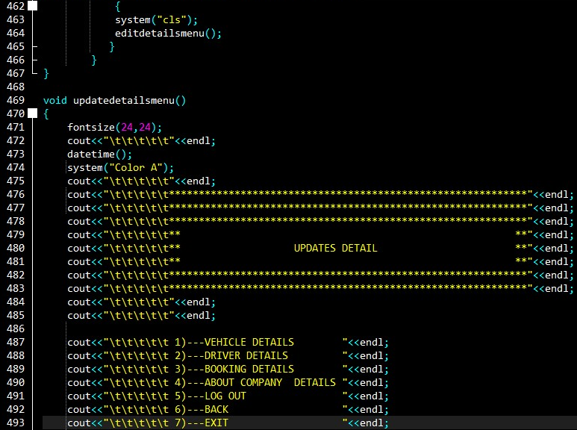

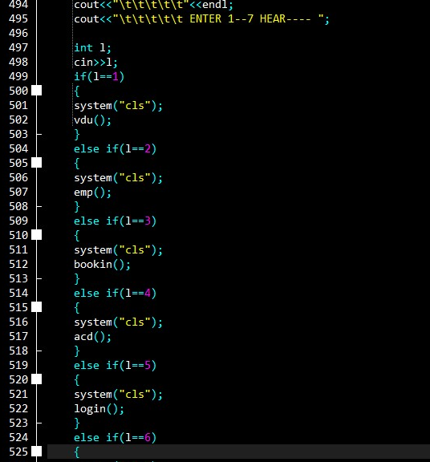

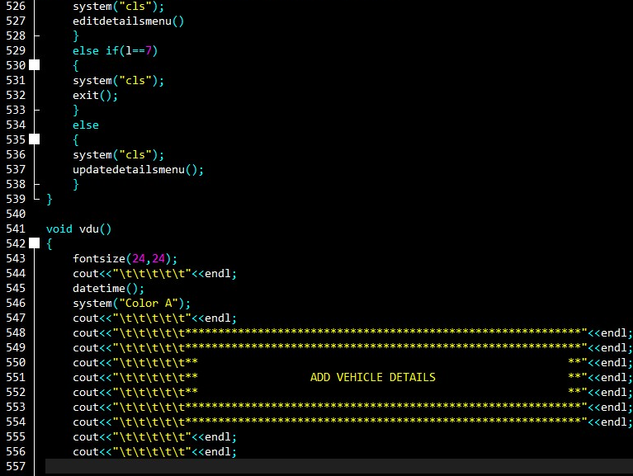

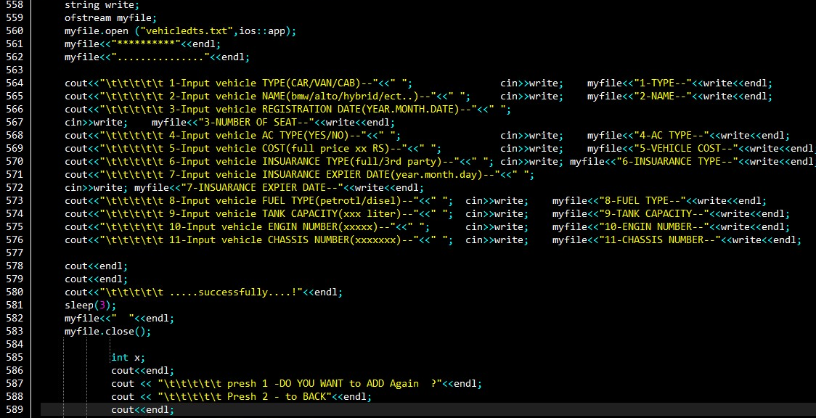

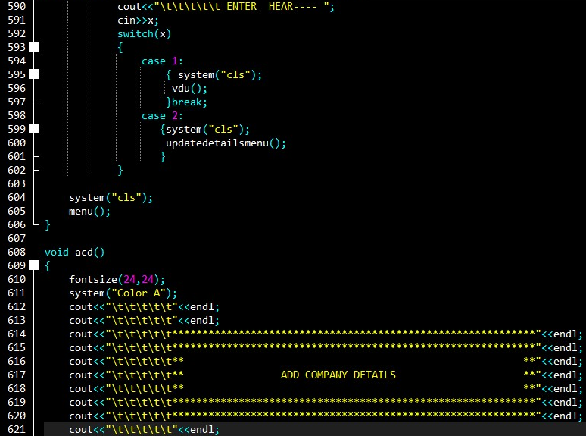

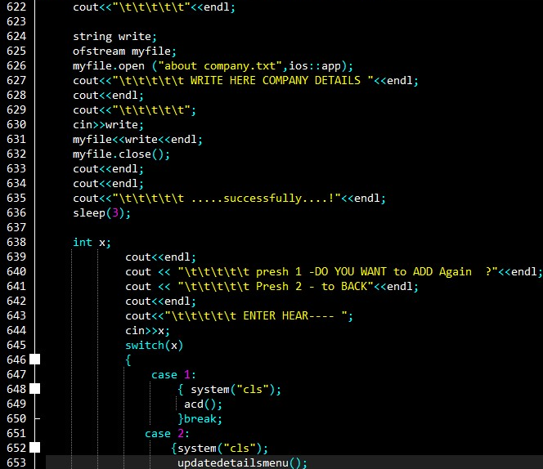

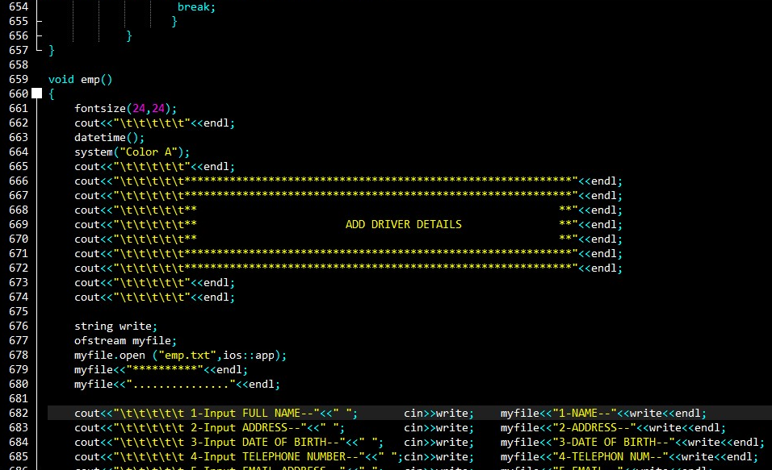

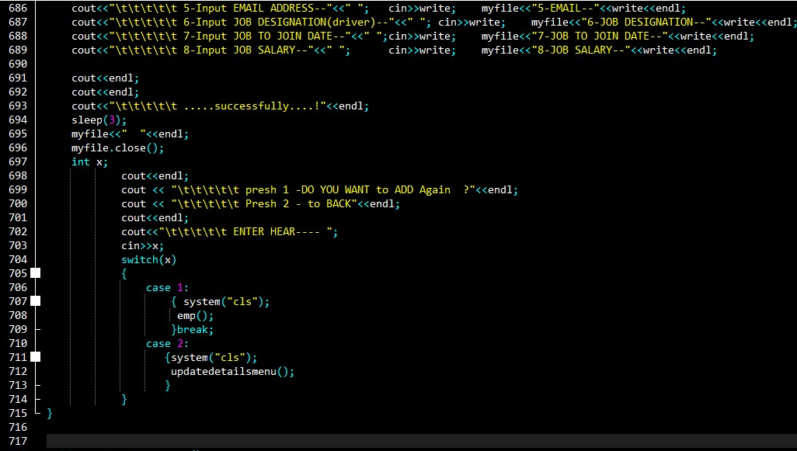

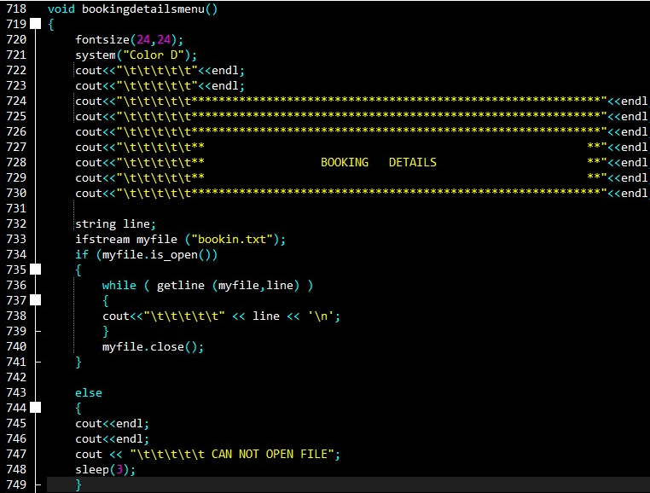

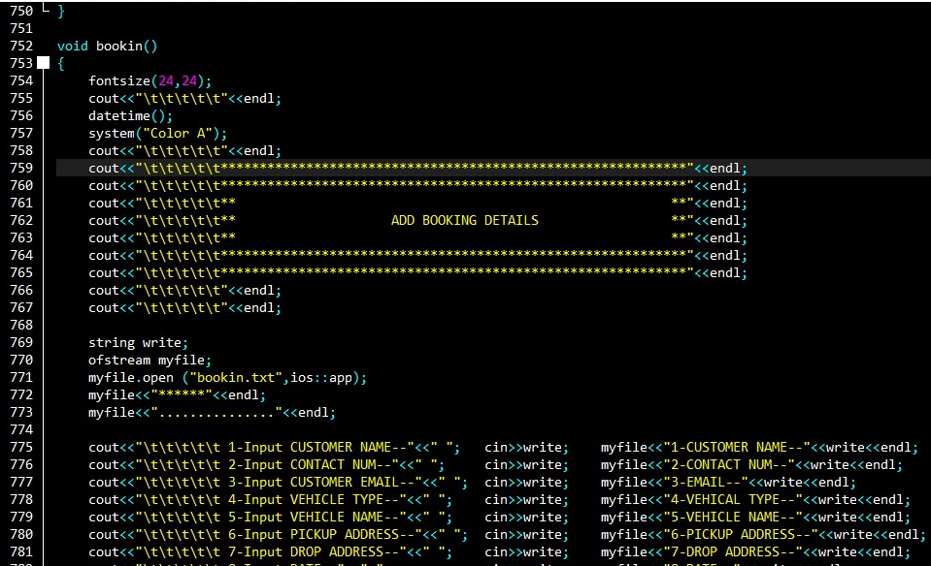

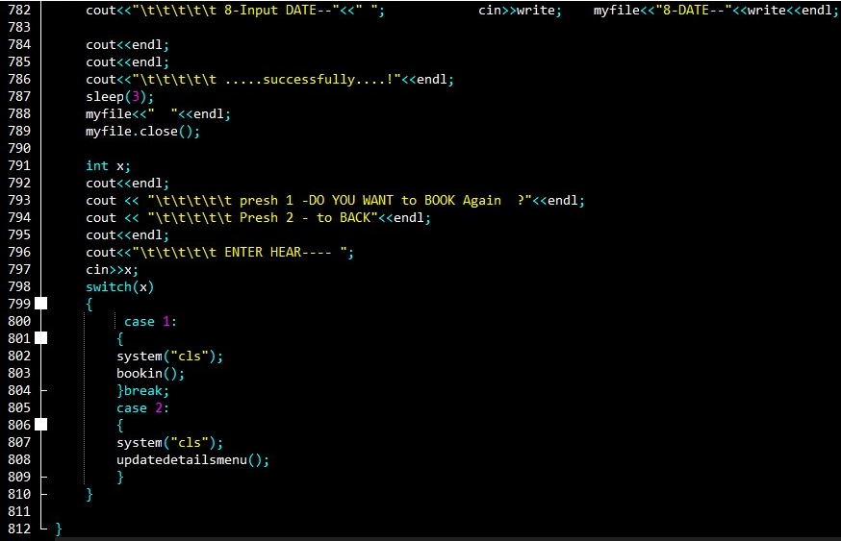

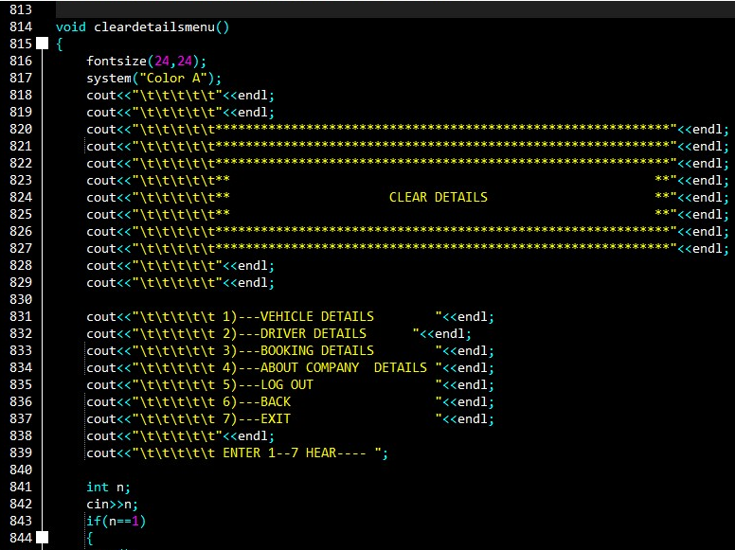

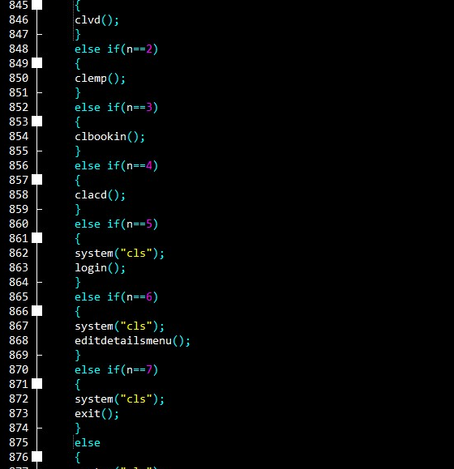

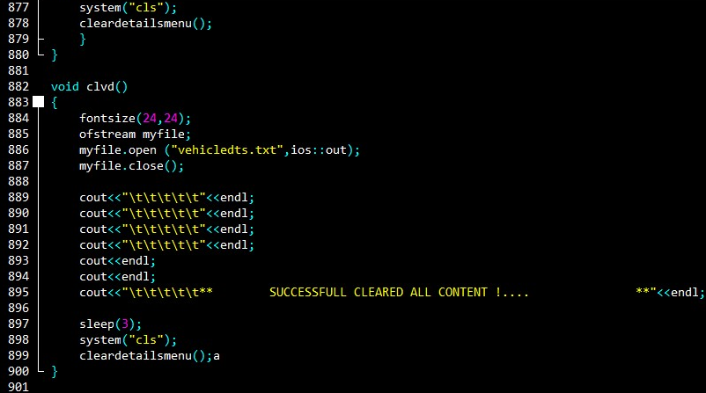

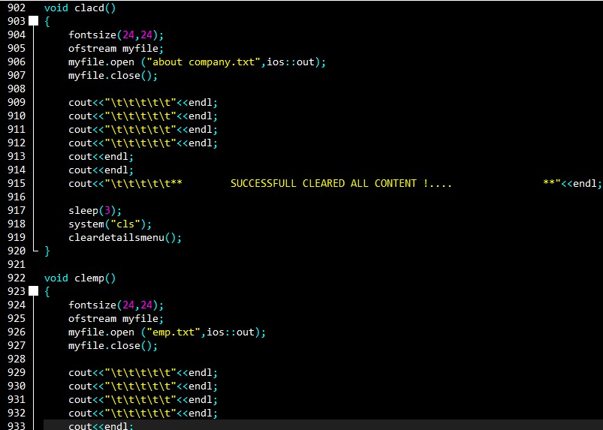

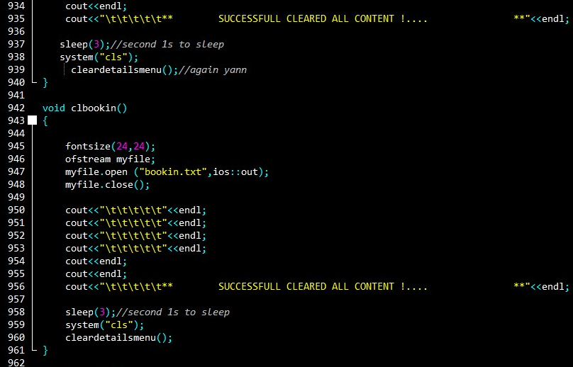

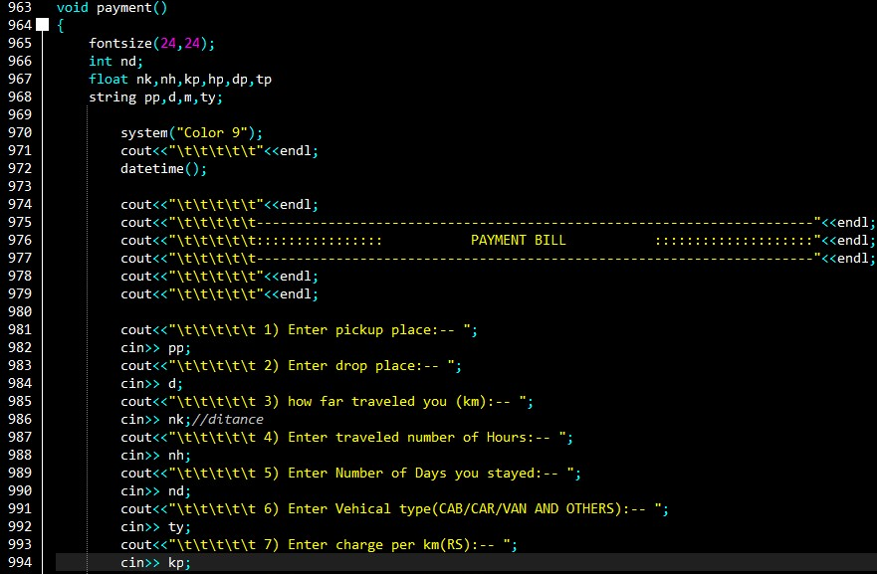

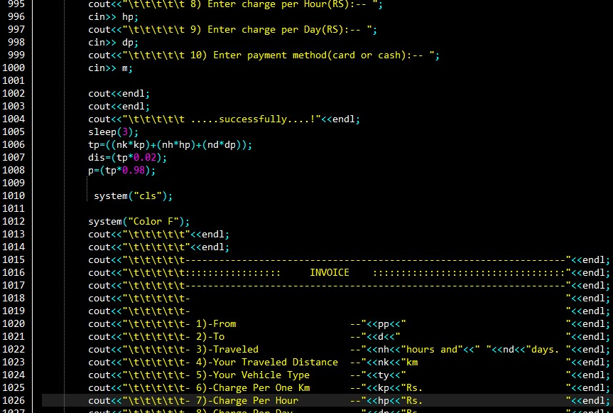

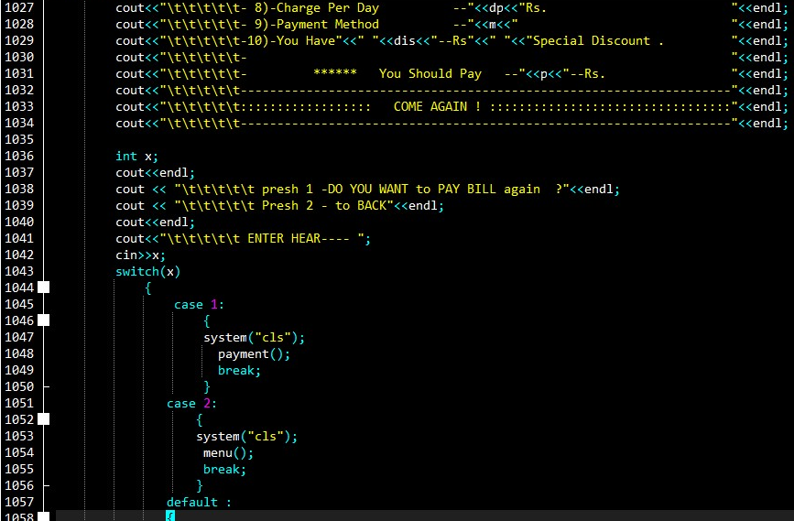

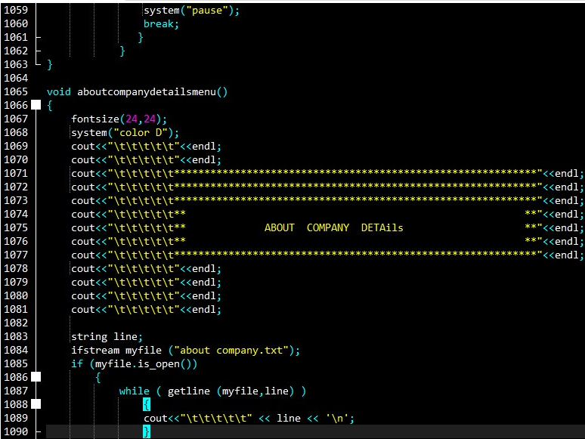

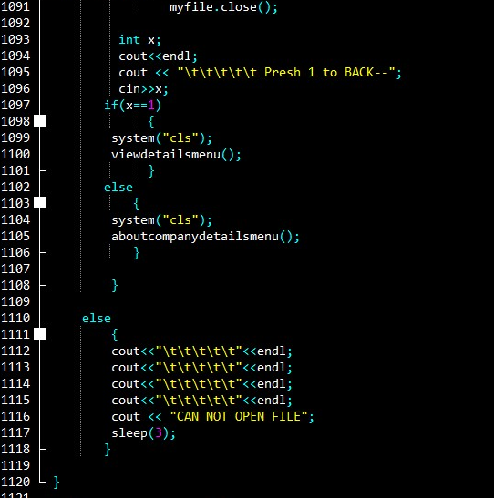

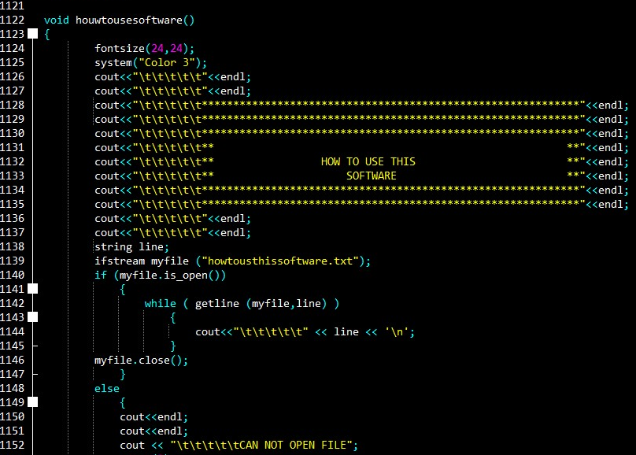

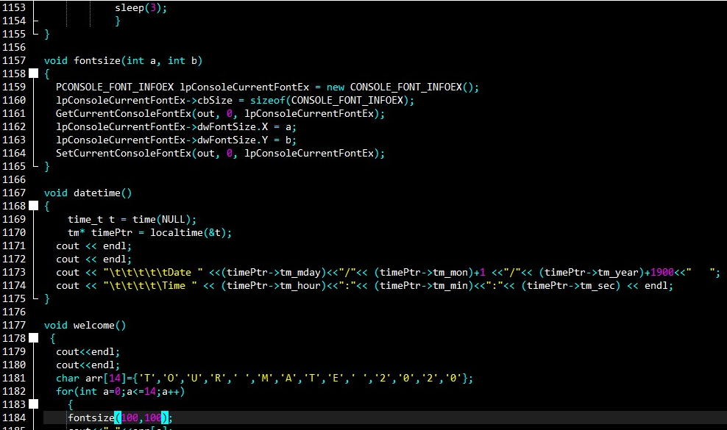

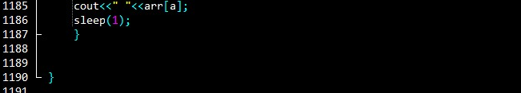

# TASK 04

## TEST CASE

|  |  |
| --- | --- |
| **Test Case NO** | 01 |
| **TEST DATE** | 2020/04/27 |
| **Test OBJECTIVE** | Check Login function with valid Data |
| **OBJECTIVE**  ID | 1 |
| **Test Data** | Username= "user"  Password = "pass99" |
| **Expected Results** | User should, Logging in to the system successfully and open the main menu. |
| **Actual Results** | Login successfully and direction to main menu. |
| **Pass/Fail** | pass |
| **Conclusion** | Expected actual output. |

### Valid details with login

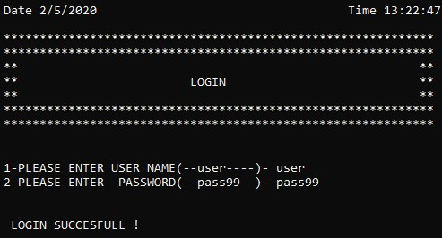

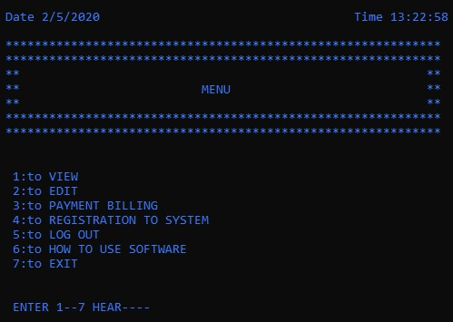

|  |  |
| --- | --- |
| **Test Case NO** | 01 |
| **TEST DATE** | 2020/04/27 |
| **Test OBJECTIVE** | Check Login function with invalid Data |
| **OBJECTIVE**  ID | 2 |
| **Test Data** | Username= "xxx"  Password = "yyy" |
| **Expected Results** | Login cancel and |
| **Actual Results** | Login fail and direction again login menu. |
| **Pass/Fail** | pass |
| **Conclusion** | Expected actual output. |

### Invalided details with login

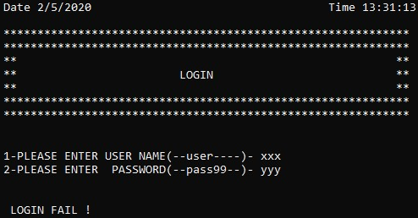

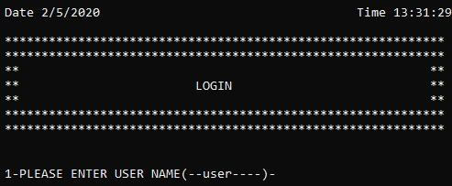

|  |  |
| --- | --- |
| **Test Case NO** | 02 |
| **TEST DATE** | 2020/04/27 |
| **Test OBJECTIVE** | Check Menu function with Data |
| **OBJECTIVE**  ID | 1 |
| **Test Data** | Enter number =1  Enter number =2  Enter number =3  Enter number =4  Enter number =5  Enter number =6  Enter number =7  Enter number =other numbers as a 9 |
| **Expected Results** | Enter number =1 after, Go to the VIEW menu and show the VIEW menu items.  Enter number =2 after, Go to the EDIT menu and show the EDIT menu items.  Enter number =3 after, Go to the PAYMENY BILLING menu and show the PAYMENT BILL items.  Enter number =4 after, Go to the REGISTRATION TO SYSTEM and show the REGISTRATION items.  Enter number =5 after, Go to the LOGGIN and show the LOGGIN MENU.  Enter number =6 after, show HOE TO USE SOFTWARE DOCUMENT.  Enter number =7 after, CLOSE THE application exit the program.  Enter number =other numbers as a Num 9 after, show the MAIN MENU items. |
| **Actual Results** | All menu function items accurately working in the system. |
| **Pass/Fail** | pass |
| **Conclusion** | Expected actual output. |

### MAIN Menu

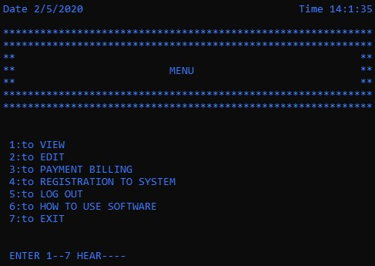

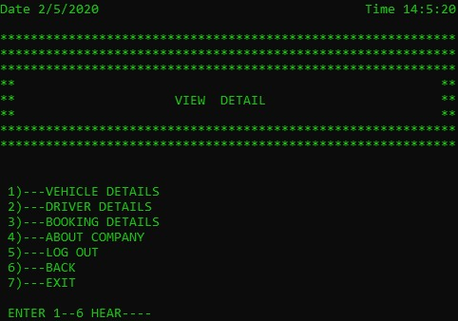

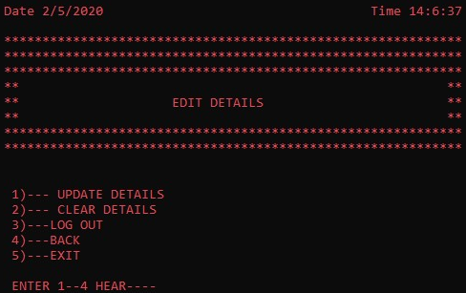

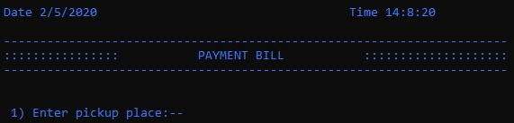

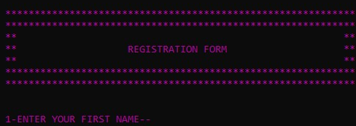

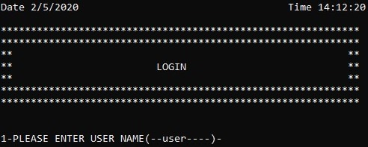

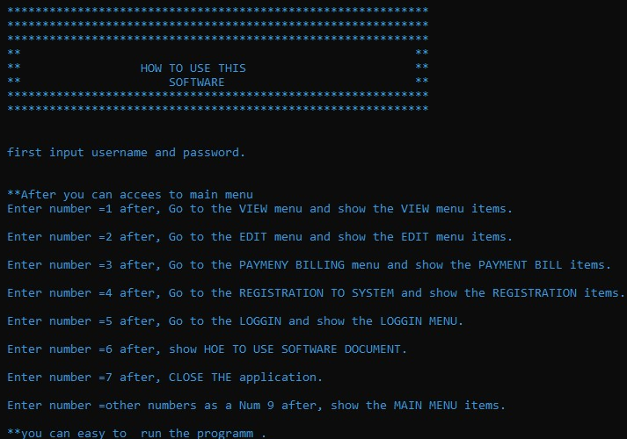

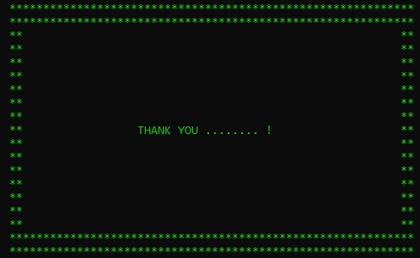

|  |  |
| --- | --- |
| **Test Case NO** | 03 |
| **TEST DATE** | 2020/04/27 |
| **Test OBJECTIVE** | Check PAYMENT BILL function with valid Data |
| **OBJECTIVE**  ID | 3 |
| **Test Data** | Pickup place ="KALUTHARA"  Drop place ="DEHIWALA"  How far travelled you(km) ="42"  Enter travelled number of Hours ="1"  Enter Number of Days you stayed ="0"  Enter Vehicle type(CAB/CAR/VAN AND OTHERS)="CAB"  Enter charge per km(RS) ="25"  Enter charge per hour(RS) ="100"  Enter charge per day (RS) ="0"  Enter payment method(cash/card) ="CASH"  Enter -1  Enter- 2 |
| **Expected Results** | Payment successfully and view the invoice to bill.  After enter-1 go to the again pay bill or enter-2 go to back menu. |
| **Actual Results** | Direction to invoice.  Enter-1 go to again pay bill successful.  Enter-2 go to the main menu successfully. |
| **Pass/Fail** | pass |
| **Conclusion** | Expected actual results. |

### Payment

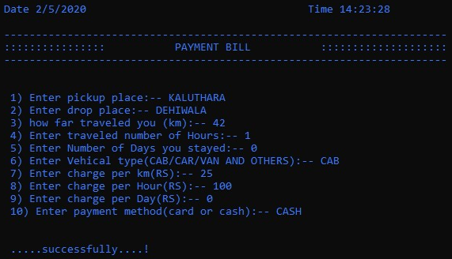

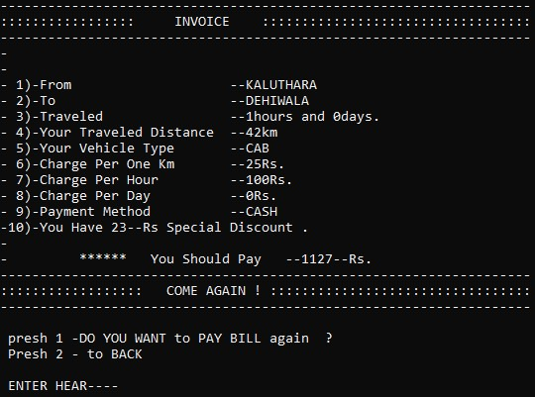

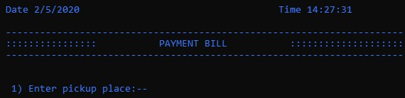

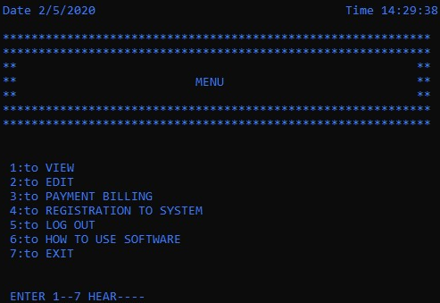

|  |  |
| --- | --- |
| **Test Case NO** | 04 |
| **TEST DATE** | 2020/04/27 |
| **Test OBJECTIVE** | Check SYSTEM REGISTRATION function |
| **OBJECTIVE**  ID | 1 |
| **Test Data** | First name = ROY  Last name =ANDERSON  Address =No.89, Benthota, Aluthgama.  Telephone number =03487959520  [Email =mohomedkalif@gmail.com](mailto:Email%20%20%20%20%20%20%20%20%20%20%20%20%20%20%20%20%20%20%20%20%20%20%20%20%20%20%20%20%20%20%20%20%20%20%20%20%20%20%20%20%20%20%20%20%20%20%20%20%20%20%20%20%20%20%20%20=mohomedkalif@gmail.com)  Password =252525kl  Again password =252525kl |
| **Expected Results** | Data enter after, view the Registration successfully massage and return to main menu. |
| **Actual Results** | Registration successfully and direction to main menu. |
| **Pass/Fail** | pass |
| **Conclusion** | Expected actual results. |

### System registration

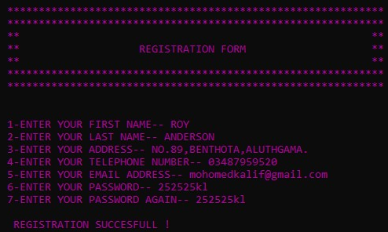

|  |  |
| --- | --- |
| **Test Case NO** | 5 |
| **TEST DATE** | 2020/04/27 |
| **Test OBJECTIVE** | Check Booking details ADD function |
| **OBJECTIVE**  ID | 1 |
| **Test Data** | customer name = SAVINDU  contact number =0785555558  Contact [Email =kalif@gmail.com](mailto:Email%20%20%20%20%20%20%20%20%20%20%20%20%20%20%20%20%20%20%20%20%20%20%20%20%20%20%20%20%20%20%20%20%20%20%20%20%20%20%20%20%20%20=kalif@gmail.com)  Vehicle type =CAB  VEHICLE NAME = BMW  Pickup place ="KALUTHARA"  Drop place ="DEHIWALA  DATE =2020.05.02  Enter -1  Enter- 2 |
| **Expected Results** | Data enter after, view the BOOKING successfully massage.  After enter-1 go to the again BOOKIN or enter-2 go to back such as update menu. |
| **Actual Results** | BOOKING successfully.  Enter-1 go to again BOOKIN successful.  Enter-2 go to the UPDATE menu successfully |
| **Pass/Fail** | pass |
| **Conclusion** | Expected actual results. |

### Add booking

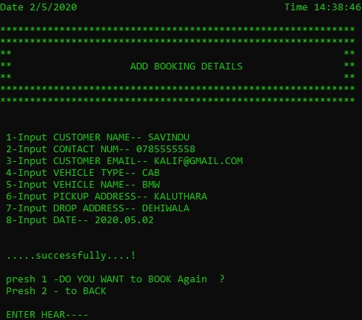

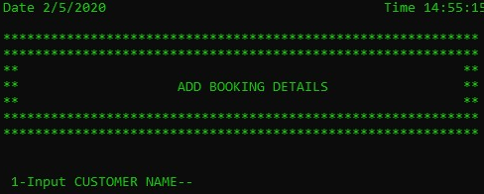

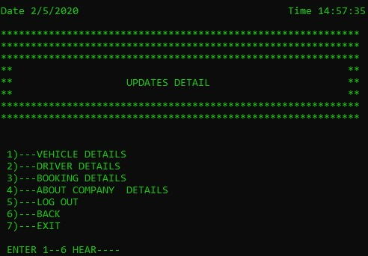

### Add drive details

|  |  |
| --- | --- |
| **Test Case NO** | 06 |
| **TEST DATE** | 2020/04/27 |
| **Test OBJECTIVE** | Check DRIVER DETAILS ADD function |
| **OBJECTIVE**  ID | 1 |
| **Test Data** | FULL name =SAVINDU PASINGTHA  DATE OF BIRTH =1988.04.25  Address =No.89, Benthota, Aluthgama.  Telephone number =0770000000  [Email =mohomedkalif@gmail.com](mailto:Email%20%20%20%20%20%20%20%20%20%20%20%20%20%20%20%20%20%20%20%20%20%20%20%20%20%20%20%20%20%20%20%20%20%20%20%20%20%20%20%20%20%20%20%20%20%20%20=mohomedkalif@gmail.com)  JOB DESIGNATION(driver) =DRIVER  JOB TO JOIN DATE =2020.03.16  JOB SALARY =28373 RS  Enter -1  Enter- 2 |
| **Expected Results** | Data enter after, view the driver details add successfully massage.  After enter-1 go to the again ADD DRIVE DETAILS or enter-2 go to back such as update menu. |
| **Actual Results** | Driver details add successfully and other option correctly work. |
| **Pass/Fail** | pass |
| **Conclusion** | Expected actual results. |

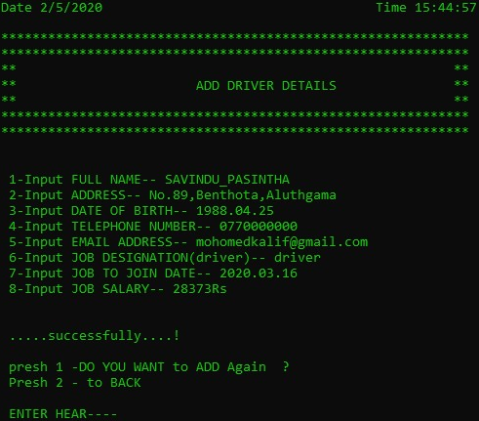

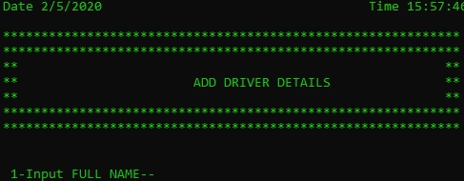

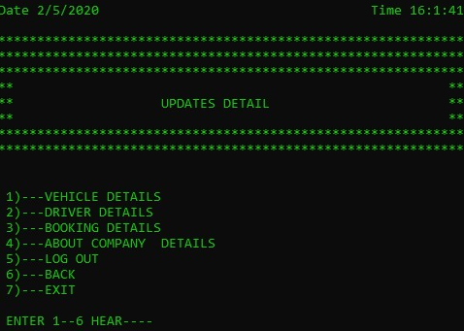Add vehicle details

|  |  |
| --- | --- |
| **Test Case NO** | 07 |
| **TEST DATE** | 2020/04/27 |
| **Test OBJECTIVE** | Check VEHICLE DETAILS ADD function |
| **OBJECTIVE**  ID | 1 |
| **Test Data** | vehicle TYPE(CAR/van /cab) = CAB  Vehicle NAME (BMW/alto/hybrid/etc.) =BMW  vehicle REGISTRATION DATE(YEAR.MONTH.DATE) =1980.05.23  vehicle AC TYPE(YES/NO) =YES  vehicle COST(full price xx RS) =4,500,000  vehicle INSUARANCE TYPE(full/3rd party) =FULL  vehicle INSUARANCE EXPIER DATE(yera.month.day) =2025.06.28  vehicle FUEL TYPE(petrol/diesel) =DEISEL  vehicle TANK CAPACITY(xxx litter) =35  vehicle ENGIN NUMBER(xxxxx) =454XY55  vehicle CHASSIS NUMBER(xxxxxxx) =P888888  Enter -1  Enter- 2 |
| **Expected Results** | Data enter after, view the Vehicle details add successfully massage.  After enter-1 go to the again ADD VEHICLE DETAILS or enter-2 go to back such as update menu. |
| **Actual Result** | Vehicle details add successfully and other option correctly work. |
| **Pass/Fail** | pass |
| **Conclusion** | Expected actual results. |

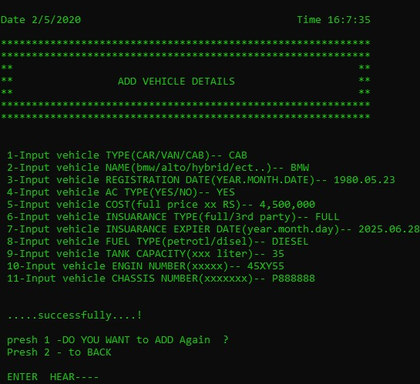

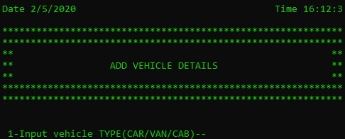

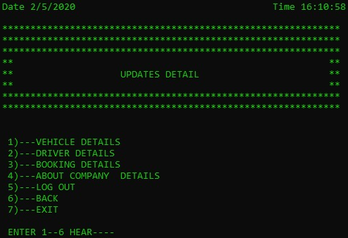

|  |  |
| --- | --- |
| **Test Case NO** | 08 |
| **TEST DATE** | 2020/04/27 |
| **Test OBJECTIVE** | Check ADD COMPANY DETAILSS function |
| **OBJECTIVE**  ID | 1 |
| **Test Data** | WRITE THE COMPANY DETAILS HERE…  Entre -1  Enter-2 |
| **Expected Results** | Add company details and after the show successfully message.  Enter-1 to again details add.  Enter-2 back to update menu. |
| **Actual Results** | View the successful message and enter options correctly work. |
| **Pass/Fail** | pass |
| **Conclusion** | Expected actual results. |

### Add company details

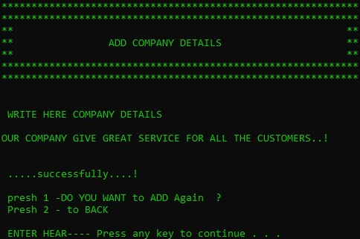

### View menu

|  |  |
| --- | --- |
| **Test Case NO** | 09 |
| **TEST DATE** | 2020/04/27 |
| **Test OBJECTIVE** | Check VIEW DETAILS MENU function |
| **OBJECTIVE**  ID | 1 |
| **Test Data** | Enter number =1  Enter number =2  Enter number =3  Enter number =4  Enter number =5  Enter number =6  Enter number =7  Enter number =other numbers as a 65 |
| **Expected Results** | Enter number =1 after, Go to the VIEW VEHICLE DETAILS and after direction the VIEW details menu items.  Enter number =2 after, Go to the VIEW DRIVER DETAILS menu and after direction the VIEW details menu items.  Enter number =3 after, Go to the BOOKING DETAILS menu and after direction the VIEW details menu items.  Enter number =4 after, Go to the VIEW ABOUT COMPANY DETAILS and after direction the VIEW details menu items.  Enter number =5 after, Go to the LOGGIN and show the LOGGIN MENU.  Enter number =6 after, Go to BACK as a view details menu.  Enter number =7 after, CLOSE THE application exit the program.  Enter number =other numbers as a Num 65 after, view again VIEW DETAILS MENU items. |
| **Actual Results** | All menu function items accurately working in the system. |
| **Pass/Fail** | pass |
| **Conclusion** | Expected actual output. |

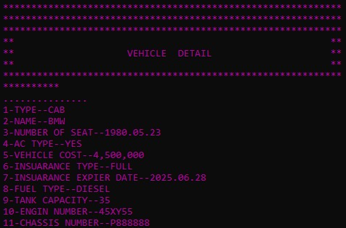

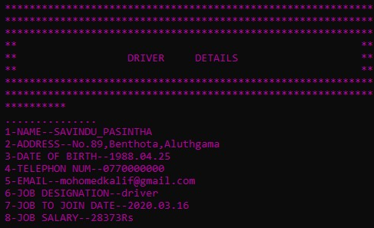

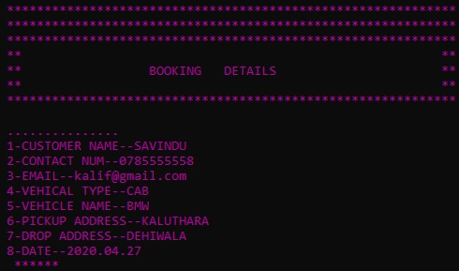

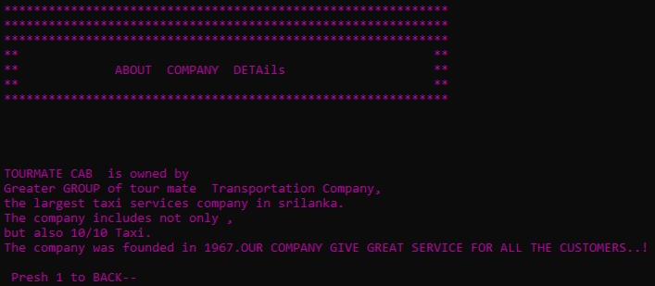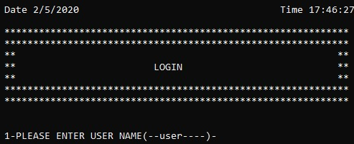

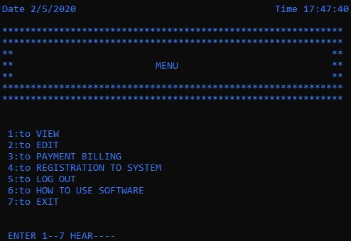



### Edit menu

|  |  |
| --- | --- |
| **Test Case NO** | 10 |
| **TEST DATE** | 2020/04/27 |
| **Test OBJECTIVE** | Check EDIT DETAILS MENU function |
| **OBJECTIVE**  ID | 1 |
| **Test Data** | Enter number =1  Enter number =2  Enter number =3  Enter number =4  Enter number =5    Enter number =other numbers as a 65 |
| **Expected Results** | Enter number =1 after, Go to the VIEW UPDATE DETAILS MENU and after direction the EDIT DETAILS menu items.  Enter number =2 after, Go to the VIEW CLEAR DETAILS menu and after direction the EDIT details menu items.  Enter number =3 after, Go to the LOGGIN and show the LOGGIN MENU.  Enter number =4 after, Go to BACK as a MAIN menu.  Enter number =5 after, CLOSE THE application exit the program.  Enter number =other numbers as a Num 65 after, view again EDIT DETAILS MENU. |
| **Actual Results** | All EDIT menu function items accurately working in the system. |
| **Pass/Fail** | pass |
| **Conclusion** | Expected actual output. |

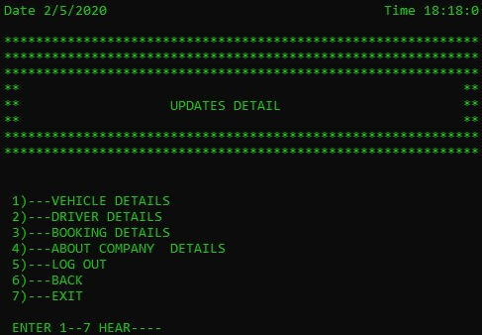

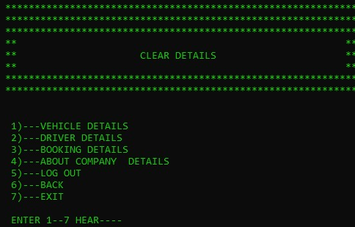

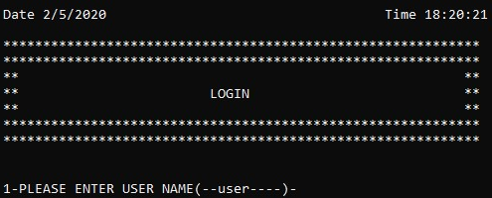

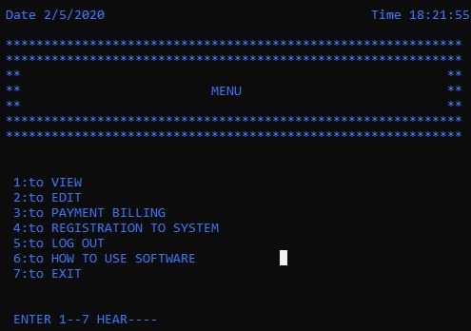



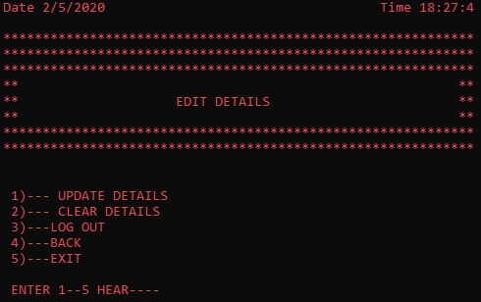

### Clear menu

|  |  |
| --- | --- |
| **Test Case NO** | 11 |
| **TEST DATE** | 2020/04/27 |
| **Test OBJECTIVE** | Check CLEAR DETAILS MENU function |
| **OBJECTIVE**  ID | 1 |
| **Test Data** | Enter number =1  Enter number =2  Enter number =3  Enter number =4  Enter number =5    Enter number =other numbers as a 65 |
| **Expected Results** | Enter-1 clear vehicle details after go to again clear details menu.  Enter-2 clear driver details after go to again clear details menu.  Enter-3 clear booking details after go to again clear details menu.  Enter-4 clear about company details after go to again clear details menu.  Enter-5 go to login menu.  Enter-6 go to the back such as edit details menu.  Enter-7 close the application and go to exit menu.  Enter number =other numbers as a Num 75 after, view again CLEAR DETAILS MENU. |
| **Actual Results** | All clear details menu function items accurately working in the system. |
| **Pass/Fail** | pass |
| **Conclusion** | Expected actual output. |

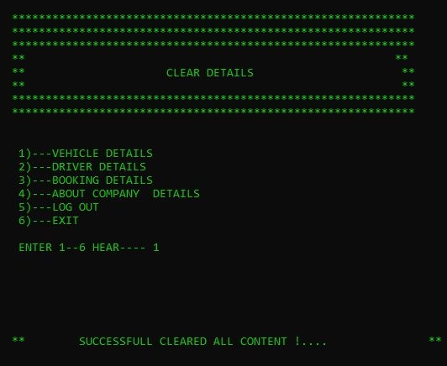

## What is testing?

Software testing is asset of process aimed at investigation, evaluating and ascertaining the completeness and quality of computer software .software testing ensure the compliance of a software product in relation with regulatory, business, technical, functional and user requirements.

### Functional testing

Functional testing refers to activities that verify a specific action or function of the code.

#### 1Unit testing-

The goal of unite testing is to isolate each part of the program and show that the individual parts are correct

#### System testing-

Testing of the system as a whole after the integration testing.

#### Integration testing-

Testing parts of the system by combining the module.

#### Acceptance testing-

Testing the system as a whole to find out if it satisfiers the requirements specifications.

### Nonfunctional testing

Non-functional testing refers to aspects of the software that may not be related to a specific function or user action, such as scalability or other performance, behavior under certain constrains, or security.

#### Performances testing-

The process of testing to determine the performance of a software product.

* Load testing-

Generally refers to the practice of modeling the expected usage of a software program by simulating multiple users accessing the program’s services concurrently. Load testing is subjecting a system to a statistically representative (usually) load. The two main reason for using such load is in support of software reliability testing and in performance testing.

* Stress testing-

A range of techniques used to access the vulnerability of portfolio to major changes in the macroenomic environment or to exceptional but plausible event.

* Endurance testing-

Endurance testing also known as Soak testing is performed to determine if the application under test can sustain the continuous loads.

* Spike testing-

Spike testing is a type of performance testing that measures an application’s ability to respond to large changes in demand volume.it is a common part of routine testing for applications in order to spot weaknesses and potential problems in a production environment.

#### Security testing-

Security testing is a process of determine that an information system protects data and maintains functionality as intended.

#### Usability testing-

User bility testing measures how easy to use and user-friendly a software system is here, a small set of target end user, “use “the software system to expose usability defects. This testing mainly focuses on the user’s ease to use the application, flexibility in handling controls and ability of system to meet its objectives. It is also called user experience testing. (Ux)

#### Compatibility testing-

This means checking that your software interacts with and shares information correctly with other software.

# CONCLUTION

The cab service application is very important to the vehicle services industries. (Vehicle hiring) I use this application to make system life cycle methodology with agile methodology. In the assignment, I have gathered information from the internet and put my full effort to finish this assignment. In addition, I put all we are experience to this. All the needed for this company and about safely and healthy way to use them by report I believe this company can maintain a successful business.

# GANTT CHART









# REFERENCE

Anon., 2011. *C# Decision Making (if, if-else, if-else-if ladder, nested if, switch, nested switch) - GeeksforGeeks.* [Online]   
Available at: https://www.geeksforgeeks.org/c-sharp-decision-making-else-else-ladder-nested-switch-nested-switch/  
[Accessed 5 April 2020].

Anon., 2013. *Programming Language Definition | Webopedia.* [Online]   
Available at: https://www.webopedia.com/TERM/P/programming_language.html  
[Accessed 18 02 2020].

Anon., 2014. *Learn C++.* [Online]   
Available at: https://www.learncpp.com/  
[Accessed 25 02 2020].

Anon., 2015. *C++ If ... Else.* [Online]   
Available at: https://www.w3schools.com/cpp/cpp_conditions.asp  
[Accessed 2 March 2020].

Anon., 2015. *how to write software reqirent specificaion.* [Online]   
Available at: https://www.perforce.com/blog/alm/how-write-software-requirements-specification-srs-document  
[Accessed 27 March 2020].

Anon., 2017. *Computer Programming.* [Online]   
Available at: https://homepage.cs.uri.edu/faculty/wolfe/book/Readings/Reading13.htm  
[Accessed 15 02 2020].

Anon., 2018. *How to write a good SRS for your Project - GeeksforGeeks.* [Online]   
Available at: https://www.geeksforgeeks.org/how-to-write-a-good-srs-for-your-project/  
[Accessed 15 March 2020].

Anon., 2018. *modularization.* [Online]   
Available at: https://www.youtube.com/watch?v=dah74-XZVXc  
[Accessed 22 April 2020].

Anon., 2019. *Sequencing, Selection or Iteration: Take the Quiz!.* [Online]   
Available at: https://www.101computing.net/sequencing-selection-iteration/  
[Accessed 27 February 2020].

Anon., n.d. [Online]   
Available at: https://launchschool.com/books/ruby/read/variables

Choudary, A., 2016. *What is a test case: The Ultimate Guide with Examples | Edureka.* [Online]   
Available at: https://www.edureka.co/blog/test-case-in-software-testing/  
[Accessed 04 May 2020].

Colleges, T., 2018. *A History of Computer Programming Languages.* [Online]   
Available at: https://www.onlinecollegeplan.com/computer-programming-languages/  
[Accessed 10 02 2020].

END... !